Magnaclave – Troubleshooting
Unable to open Door

**Note, All test are performed with unit in vent mode.
***All tests are to be performed by an experienced service technician as many tests are performed with hazardous electrical voltage that can produce electrical shock or death. When possible disconnect power or turn off breaker to machine to reduce potential shock hazard.

- Verify Door Open light is on, if door open light is not on check pressure in the chamber by pulling the safety valve and removing all pressure in chamber.

- If still no Door Open light check voltage between the power switch red wire # 34 and the function switch white wire # 10 with the machine in vent and measure for line voltage 220Vac. If voltage is not present replace the function switch part # 004079.
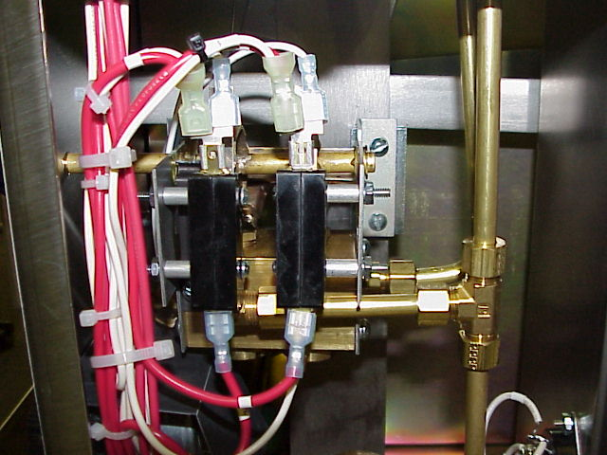
Red Wire 34 to
White Wire # 10

- If voltage is present in step 2 and still no Door Open light check continuity across 1 lb pressure switch. If no continuity across switch with no pressure in machine replace switch part # 004461
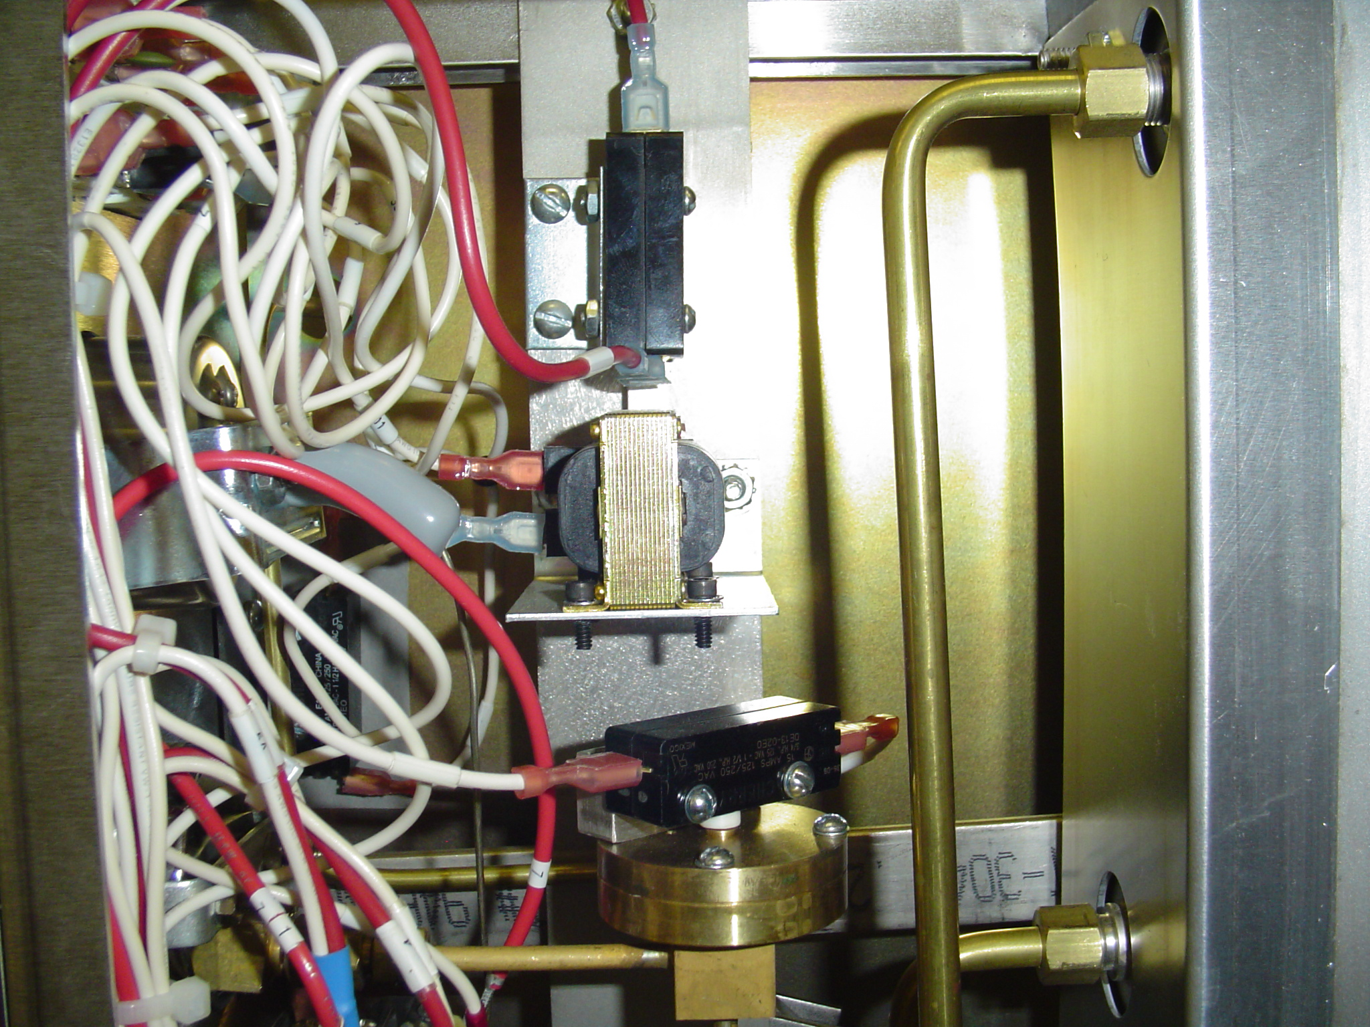
Check Continuity across 1 pound pressure switch

Next page

- If Door Open light is on and door will not open check door open switch continuity; when pressing switch it should have continuity across switch. If no continuity when pressing switch replace switch part # 004467
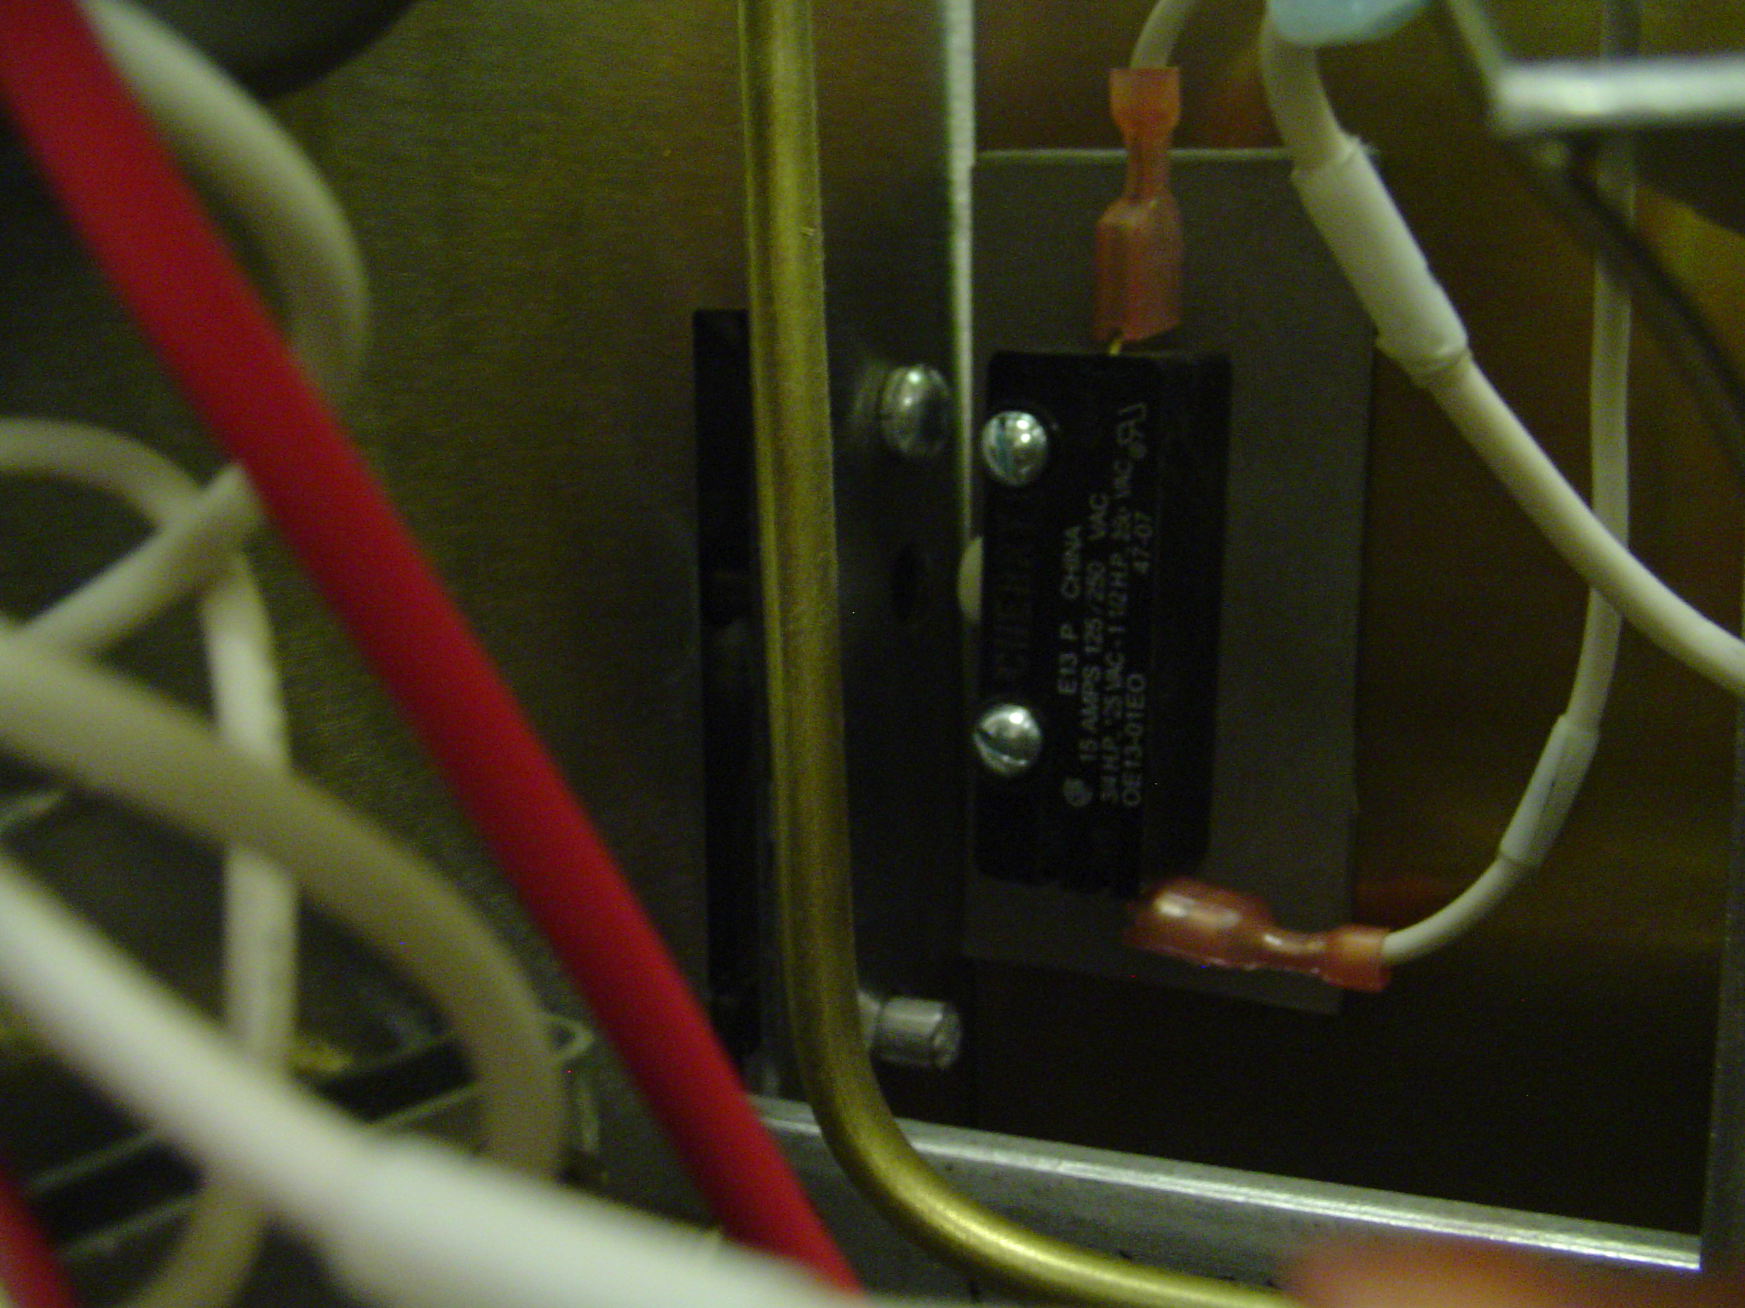
Check continuity across door open switch while pressing switch

- If door still will not open check resistance of door solenoid with wires disconnected. Resistance should be approximately 185 to 200 ohms. If resistance is infinite replace solenoid part # 5473041.
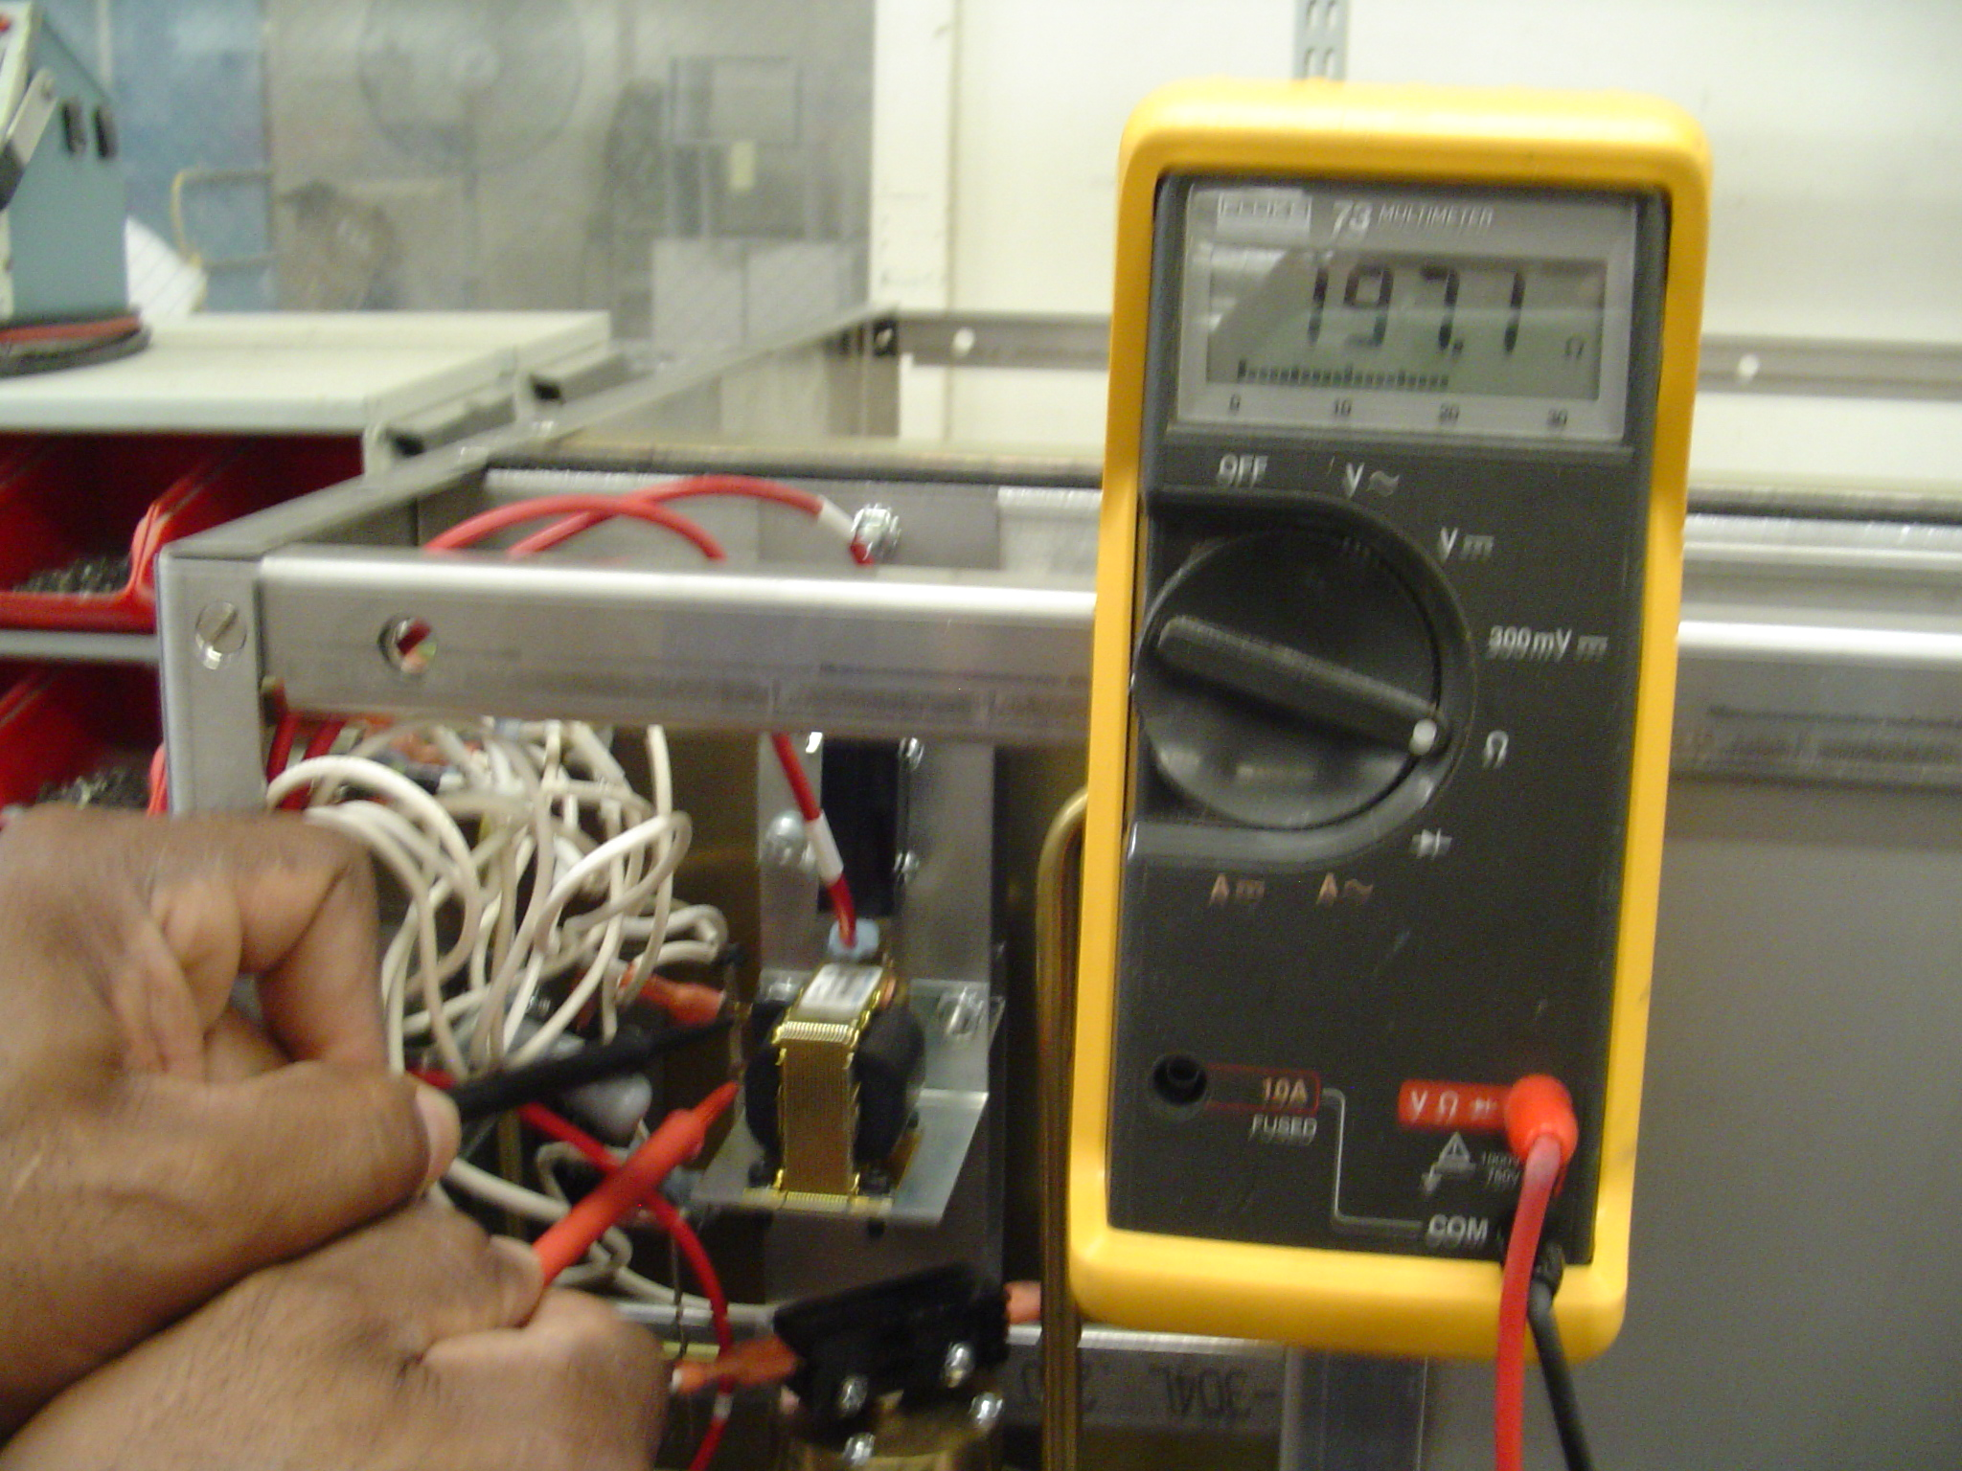

Next page

- If door still will not open disconnect wires from solenoid and check voltage across solenoid white wires # 2 and # 11 when pressing the door switch. Voltage should be line voltage 220Vac. If voltage not present repeat previous steps and recheck all wiring connections.
Check voltage across white wires #2 and #11 while pressing door switch

JDH

